Energy

What is Energy?
- Energy is needed to make things move or change
- Some substances and objects may have many forms of energy at the same time
- Living things need energy
- Energy exists in many different forms
- Energy can change from one form to another
- Energy is not a substance. It cannot be weighed and doesn’t take up any space.

Active or Stored?
- Active energy occurs in action and is detected when particles, waves or objects move. For eg light, heat, electrical, sound, kinetic
- Potential energy cannot be detected until it changes into active energy. The energy is stored because of their position in space or their nature. For eg chemical, magnetic, gravitational, nuclear, elastic

In groups, construct a poster on Energy. You can choose to focus on active energy types or potential energy types.

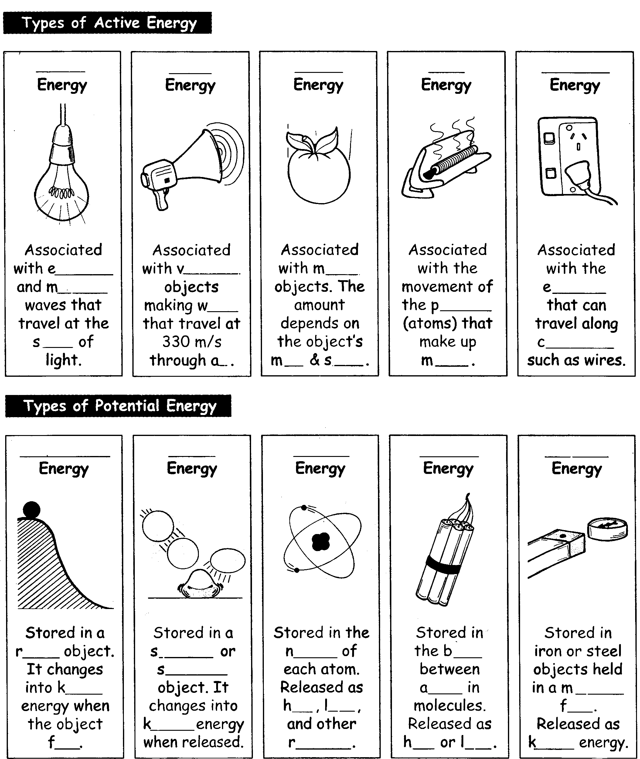

Energy Forms
Homework Sheet

- State whether each of the following is true or false:
- Energy is not a substance b) Energy is needed to make things move
- Stored energy is called kinetic energy d) Energy can be weighed
- Heat is a type of active energy f) Objects can have energy
- Light is a type of potential energy h) Only moving things have energy

- Identify the energy form(s) involved in each of the following situations
a) A child sitting at the top of a slide b) an ice cream
c) power lines d) A can of petrol
e) A hydrogen atom f) A ringing bell
- A stove element that is switched on

- Decide whether the following objects or events involve active or potential energy. Some examples may involve both types of energy.
Object or Event | Active energy | Potential energy
Battery inside a silent radio
Stereo playing rock music
Frisbee flying in the sky
Petrol can falling to ground
Cake taken out of the oven
Ball rolling down a slope

Energy Changes
- Energy changes happen when:
- Energy is transferred from one object to another object. For eg: Heat energy will be transferred from a fire to your body.
- Energy is transformed into other forms. For eg: a lamp will transform electrical energy into light and heat energy.
- Often when energy is transformed, several new types of energy appear. For eg in a car, the chemical potential energy in petrol transforms to kinetic, heat and sound energy.
- Sometimes energy transfers and energy transformations occur one after another in an energy chain. Eg chemical potential energy→electrical energy→heat and light energy

Energy changes and Transformations
Homework sheet

1.For each example below, name the energy form being transferred
- In a game of pool, the white ball hits the black ball, causing the black ball to move
- A bed becomes hot when an electric blanket is switched on
- A sail boat is pushed along by the wind
- A rabbit eats grass
- Food is eaten by a growing child

2. Fill in the gaps in the following:
a) A fire changes i energy into ii and iii energy
b) A battery changes i energy into ii energy
c) A skydiver changes i energy into ii energy
d) A fan changes i energy into ii and iii energy
e) A computer changes i energy into ii and iii energy and iv energy

- Write down, using energy equations, the energy changes that occur in each of the following situations: Eg electrical energy → heat energy + light energy

a) a light bulb b) television
c) guinea pig running on the ground d) a child sliding down a slide
e) a car moving at constant speed f) a plant leaf in sunshine

- In a playground, energy is often being transformed from one type to another. Name the type of energy that a child has at each of the lettered points below:
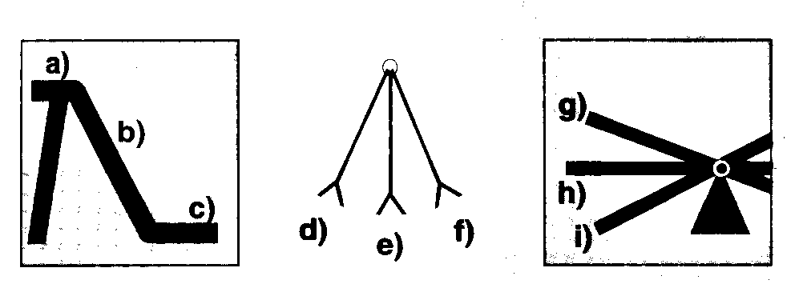
5. Complete the energy story given using words form the list(may be used more than once)
chemical potential, gravitational potential, heat, light, nuclear potential, kinetic, sound, transferred, transformed
The sun transforms i energy into ii and iii energy. A plant transforms the iv energy from the sun into v energy. A rabbit eats the plant and the vi energy form the plant is vii to the rabbit. The rabbit transforms the viii energy
into ix energy as it runs and x energy to keep warm.

Observing Energy Changes

Aim: To observe the energy changes that occur in a variety of situations.

Preparation: Draw up a data table like the one shown below. For each activity, you will record the energy change(s) that occurred and whether there was an energy transfer or transformation. (You may need to discuss this with your partners). Carefully read instructions for each activity before you start.

Activity | Observations | Energy change(s) | Transfer or transform?

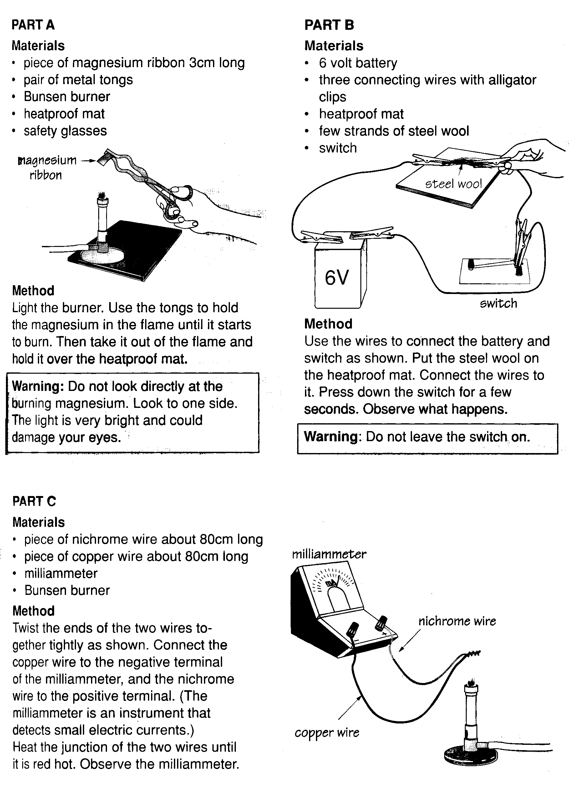
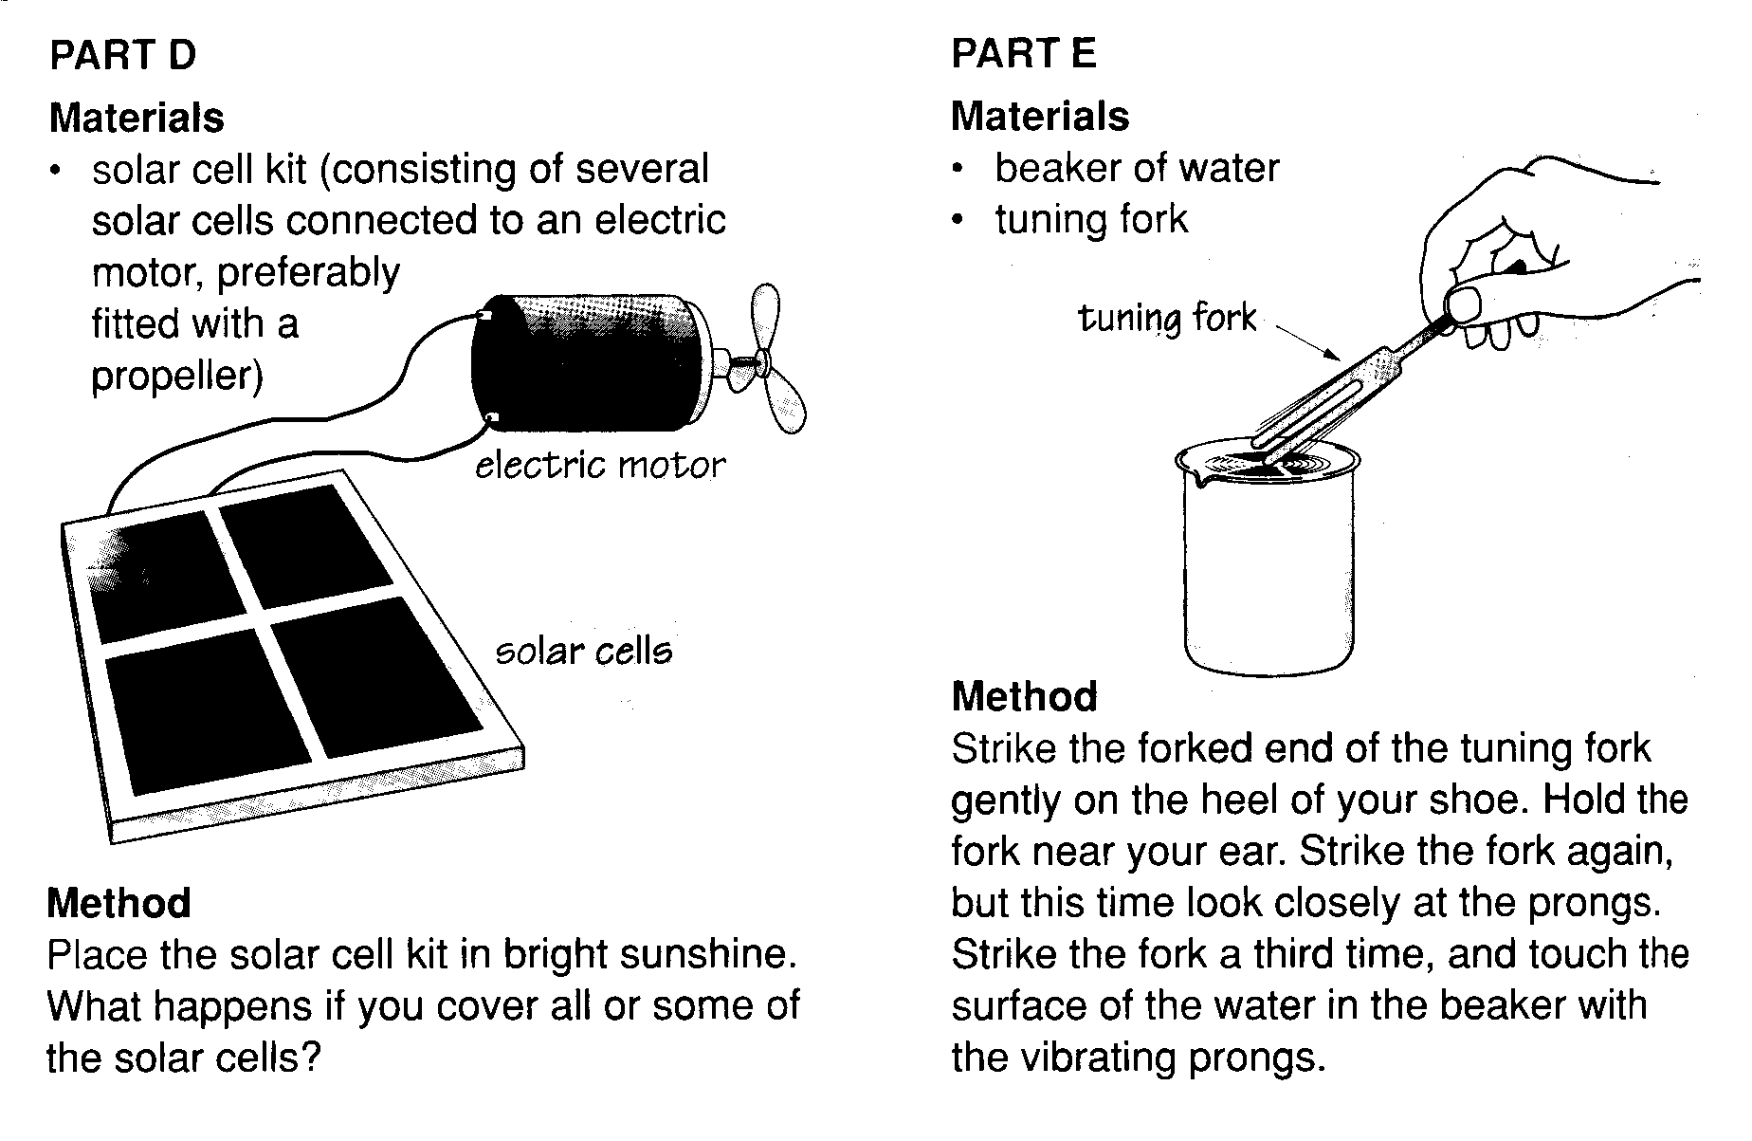
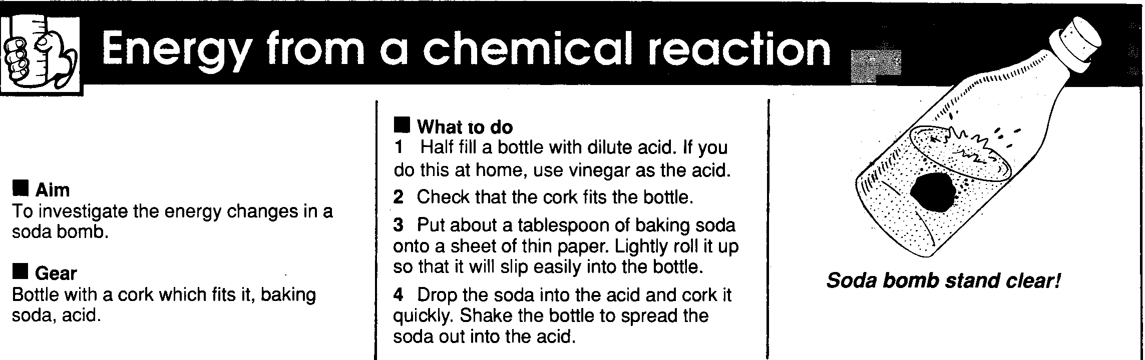

The turbine is made from a test tube with 2 bent plastic straws passed through the bung, suspended from a retort stand.
Remember to keep the flame low so as not to melt the straws.

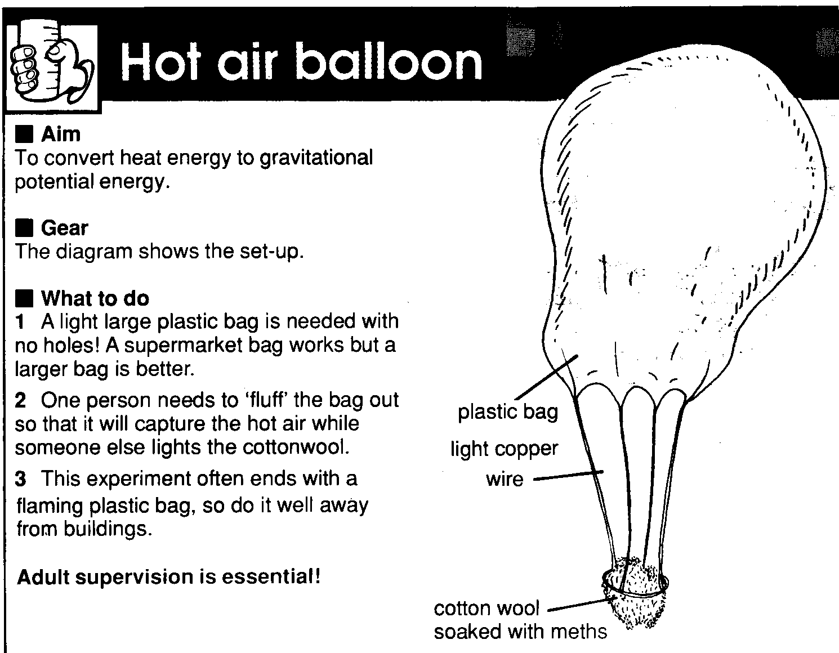

Energy Conservation
- When energy changes form- it is conserved – the amount of energy started with must be the same as the amount of energy transformed or transferred.
- The principle of Energy Conservation
Energy cannot be created or destroyed but can change form. The total amount of energy always stays the same.
- This principle can be broken down into 4 parts:
- Energy must come from somewhere ( it can’t be created)
- Energy can’t be destroyed
- Energy can change into other forms
- Energy in= Energy out

Measuring and Using Energy
- The scientific unit for energy is the joule (J). One joule is a very small amount of energy so kilojoules kJ, are often used. 1000J = 1kJ

- The amount of energy that is transformed in a machine every second is the power rating (also called wattage). Power is measured in watts, W. One watt is exactly the same as one joule per second: 1W = 1Js⁻¹

Energy involved in everyday activities  Energy involved in burning a match  Energy you gain by eating a chocolate biscuit  Energy needed to boil a jug of water  Energy used in walking 5km  Energy gained from food you eat in one day  Electrical energy used by a family home each day  Energy stored in 5L of petrol | Kilojoules  10  400  700  1000  11 000  80 000  200 000

Fuelling Up
- Animals and humans need food to provide chemical potential energy to keep their bodies running. The exact amount varies between individuals. The average is about 11 000 kJ per day.
- On most days, the amount of energy we eat is the same as the amount of energy our body uses. If the amount in is greater than out, we store it as fat. To lose weight, you have to eat less energy than your body uses.
- Energy is needed for growth, movement, heart beating, brain ticking over, digestion.
- To find out how much energy is in food, the chemical potential energy must be transformed into active energy by burning it and seeing how much heat is given off to heat up some water.
- If you heated 1mL of water by 1ºC, then the water would gain 4.2J of heat energy.

Video – energy conservation and use

Energy in a Peanut

- Measure 20mL of water into a test tube and record its temperature:

- Heat the peanut in the bunsen flame until it starts burning. Remove
the burner and use the flaming peanut to heat the water. Hold as close
as possible.

- When the peanut has completely burned, measure the temperature of
the water.

4. What is the difference in the temperature of the water?

The energy transferred to the water from the peanut can be found in the following equation: Energy = 4.2 * mass of water * change in water temperature

Calculate the energy for your peanut:

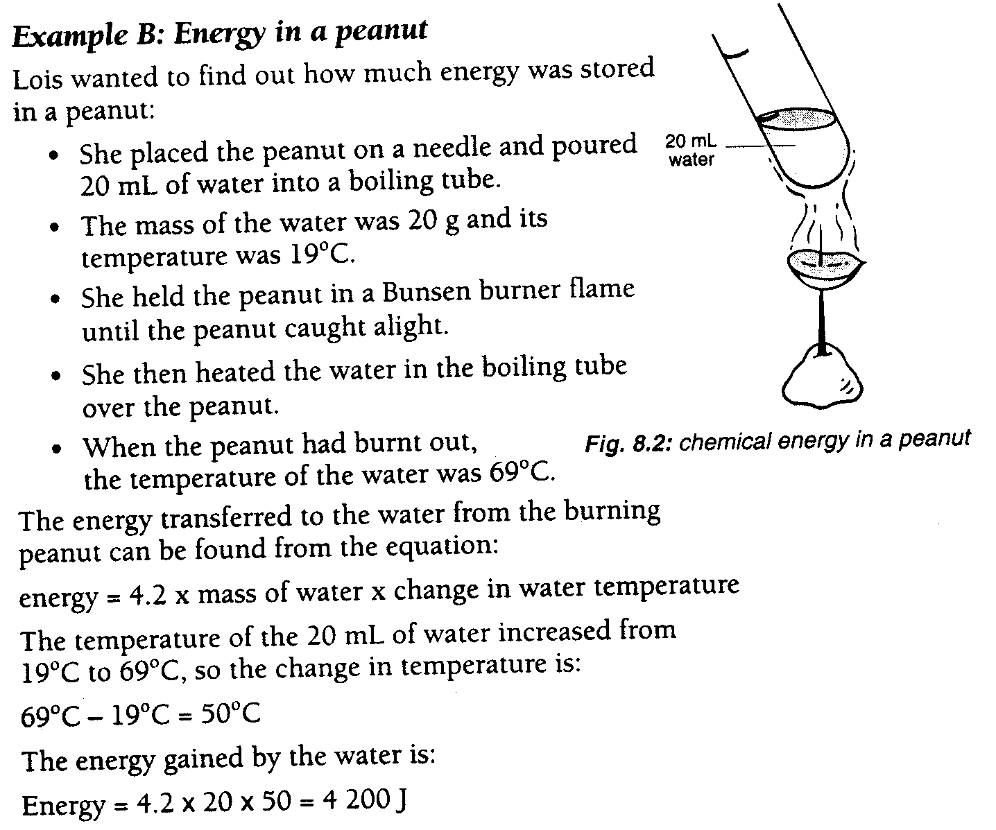

Measuring Energy
Homework Sheet

- Change the following energy values into kilojoules
a) 1000J b) 45 000J c) 150 000J d) 370000J

- Robyn wanted to find out the energy in a walnut. Below is her report.
AIM: To find out the energy in a walnut
METHOD:
- Measure 30mL of water into a test tube and measure its temperature
- Set the walnut alight and hold it under the test tube of water
- When the walnut has completely burned, measure the water temperature again.
RESULTS:
- Mass of water = 30g Starting temperature = 18ºC Final temp = 95ºC
- Change in temperature =
- Energy = 4.2 * mass of water * change in temperature =

- what was the change in temperature of the water?
- How much energy was gained by the water?

Robyn looked in a book and found the energy stored in a walnut is 10.2kJ. Her value was less. She repeated the experiment several times and got the same results each time. She concluded that “not all the heat energy from the walnut was absorbed by the water”

- What happened to the rest of the heat energy?
- State two other reasons why her value might not be exactly the same as the textbook value.

3.Andrew wanted to find out how much energy he ate in one day. He recorded all the food he ate and looked up the energy content of each food.
Meal | Food eaten | Energy (kJ)
Breakfast | 1 bowl muesli (45g) | 760
 | 200mL milk | 560
 | 2tsp sugar | 194
 | Banana | 350
 | 1 glass of orange juice | 200
Morning tea | 2 biscuits | 300
 | 250mL chocolate milk | 1088
Lunch | 4 slices of white bread | 1684
 | 2 slices of cheese | 874
 | Apple | 260
Afternoon tea | 2 biscuits | 300
 | 2 slices bread | 842
 | 1 glass cordial | 200
Dinner | 1 piece steak (150g) | 1100
 | Mixed vegetables | 250
 | 3 potatoes | 500
 | ½ tin fruit salad | 548
 | 1 serving ice cream | 600
Supper | 1 c white coffee (2t sugar) | 208
 | 1 slice white bread | 421
Total energy |  | 11 239

- What was Andrew’s total energy intake in joules?
- Why is energy content of food measured in kilojoules instead of joules?
- How much energy is in one slice of white bread?
- How much energy is in 1 tsp of sugar?
- Which meal contained the most energy?
- What form or forms of energy was the chemical potential energy in the food transformed into?
Using the graph below
- Andrew is 13 years old. Is Andrew’s energy intake about right for his age?
- How much energy does a 20 year old woman need each day?
- Andrew’s sister needs about 6 500kJ per day. How old is she?
- Andrew’s 17 year old brother is a racing cyclist. He takes in about 14000kJ of energy each day. Why does he need so much energy?

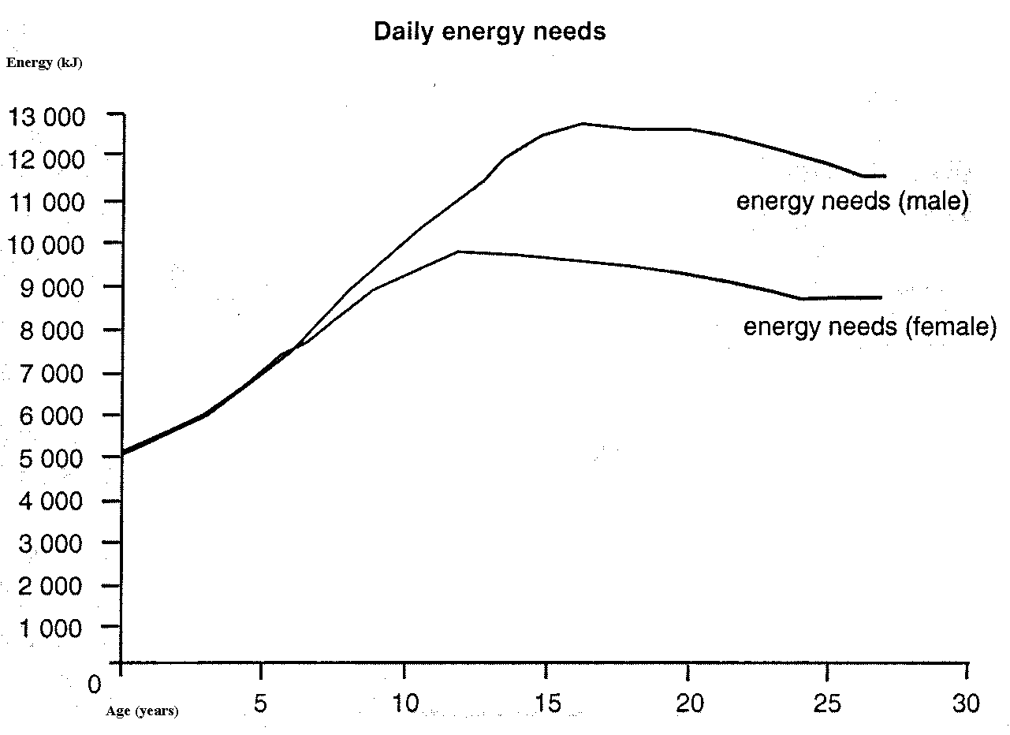

- How much energy is transformed in each of the following appliances every second?
a) 1200W heater b)650W microwave c) 85W sewing machine

- Calculate the power rating of :
- An iron that transforms 1200J of energy into heat energy each second
- A light bulb that transforms 6000J of energy into heat and light energy in one minute
- A toaster that transforms 4000J of energy into heat energy in five seconds
- A vacuum cleaner that transforms 72 000 J of energy into other forms in one minute

- Tawhiri wanted to find out how much electrical energy he used each day. He ruled a table in his book as shown:
Appliance | Power rating (W) | Energy per min (J) | Time used (min) | Energy per day (J) | Energy per day (kJ)
Stereo | 2 400 | 144 000 | 45 | i | ii
Electric blanket | iii | 7 200 | 150 | 1 080 000 | 1 080
Light | 75 | Iv | 120 | 540 000 | v
Microwave | 650 | 39 000 | 40 | vi | vii
Television | 800 | viii | ix | 9 600 000 | 9 600

- Complete the table by filling in i-ix
- Which appliance used the most energy each second?
- Which appliance used the most energy in one day?
- Which appliance was used for the longest time?
- Plot a bar graph of the power rating of each appliance. Remember labels and units and title etc…

How much Electricity does your home use?

Your power at home is measured in kWh. This means the number of kilowatts (1kW=1000W) used per hour. At present, each kWh costs 6.56c in Dunedin. You also pay $1.01 per day for the use of electricity.

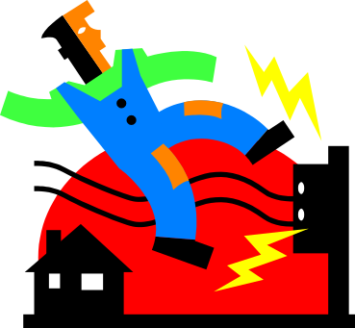Your task is to record your kWh readings every day for a week and complete the tasks below. Get a parent to show you where the meter is and help you to read the number. It could be quite a large number.
- Make sure you read the meter at the same time each day. Enter into the box below
- Each day subtract the reading of today from yesterday to calculate how much was used in the day.

 | Day 1 | Day 2 | Day 3 | Day 4 | Day 5 | Day 6 | Day 7 | Day 8
Reading
KWh
Daily usage

Tasks:
- Construct a bar graph of the daily usage for the 7 days
- Which two days were the weekend? Why did decide this?
- Why will your usage vary throughout the year?
- What was your total usage for the week in kWh?
- Calculate your power bill for the week using the figures at the top for daily usage and the amount per kWh.
- Use this to estimate your power bill for the year. Give reasons why this estimate may not be very accurate.

Now complete the Energy Audit of your Home on the next sheet

Useful and Waste Energy
- Total energy in = total energy out
- Not all energy is converted into the type of energy wanted. Energy in “wanted form” is called useful energy. Energy not in “wanted form” is called waste energy.
- Eg lightbulb produces light and heat energy. Light is the useful energy. Heat is the waste energy

6J light energy
60J

Electrical energy 54J heat energy

Energy Efficiency
- The percentage of energy that is useful is the efficiency of a machine

Efficiency = amount of useful energy produced * 100
Total energy transformed

- Eg Efficiency of lightbulb = 6 ÷ 60 *100 = 10%

The Economics of Speed

The benefit of driving faster is saving time- the model below calls this the marginal benefit. For every hour of time saved is equivalent to earning $10 per hour.
The costs of driving faster include the cost of extra fuel consumed by the car. Petrol at present is $1.08 per litre.
- Complete the following table for a trip of 120km (here to Oamaru)
Speed (kmh) | Time taken to travel 120km | Time saved by going 10kmh faster | $ marginal benefit | Litres per 100km | Litres used in 120km | Extra litres used in going faster | $ marginal cost
60 | 2 hours | - | - | 8.5 | 10.2 | - | -
70 |  |  |  | 9.0
80 |  |  |  | 9.5
90 |  |  |  | 10.5
100 |  |  |  | 12.0
110 |  |  |  | 14.0
120 |  |  |  | 16.5

- Graph marginal costs and benefits and work out the optimal speed. (Speed is on x axis and you will need two y axes up each side: costs on one side, benefits on other. Give each line a key)
- Explain how a speed o 120kmh is not optimal
- The litres used to travel 100km are generalised. What are some factors that the actual figures depend upon?
Energy Efficiency
Homework Sheet

- For each of the following, name the form(s) of waste energy produced:
- car engine – produces kinetic, heat, sound energy
- computer printer – produces kinetic, heat, sound energy
- bar heater – produces heat and light

- A vacuum cleaner uses 1 400 J of electrical energy each second to produce 300J of useful energy
- How much waste energy does the vacuum cleaner produce?
- What is the efficiency of the vacuum cleaner?

- Complete the table below:
Appliance | Total energy transformed each second | Useful energy produced (J) | Waste energy produced (J) | Efficiency (%)
Light bulb | 60 | 54 | 6 | 10
Fluorescent tube | 85 | 16 | A | B
Heater | 1 200 | C | D | 95
Electric motor | 240 | E | 96 | F
Radio | G | 45 | 30 | H

- A television transforms 800J of energy each second. It is 80% efficient.
- How much useful energy does the TV produce each second?
- How much waste energy does the TV produce each second?
- Draw a pie graph showing the energy efficiency of the television

- Linda read an advertisement for a gas stove. She wondered whether a gas stove element was more energy efficient than an electric stove element. She checked that the power rating of the electric element was the same as for the gas element.
She measured both elements. They were 14cm across.
Linda chose a pot that had a 14cm base and poured 200mL of water into the pot. She measured the temperature- it was 20ºC.
Linda placed the pot on the element and heated the water for 3 minutes without stirring it and without a lid on it. Then she measured the temperature again. At the end it was 76ºC.
She followed the same steps using the gas element. The temperature after 3 minutes was 87ºC.
She repeated the experiment with similar results

- Name three things that needed to be controlled in this experiment (kept the same)
- Why did she choose a pot that was the same size as the elements?
- What was the change in temperature of the water for: I) the gas element ii) electric element?
- Calculate the energy gained by the water using both elements. (Remember energy = 4.2*mass of water * change in temperature)
- Which element was the most energy efficient?
- Why did Linda repeat the experiment?

Heat Energy
- Particles in most objects are constantly moving. As particles are moving, they have kinetic energy.
- Heat energy is a measure of the kinetic energy of the particles in a substance.
- When heat energy is added to an object, the particles move more quickly and become further apart. This causes the object to expand.
- Solids expand the least because there are strong attractive forces between particles. Gases expand the most.
- When an object loses heat energy, the particles slow down and move closer together. This is called contraction.
- The temperature of a substance is a measure of the average kinetic energy of the particles in a substance.
- A thermometer is used to measure temperature. Thermometers contain mercury or alcohol. When the bulb is placed on or in a hot object, heat energy is transferred to the bulb of the thermometer causing the liquid to expand up the thermometer tube.

⇒A good exercise in writing up a scientific report.

- The amount of heat gained or lost by an object depends on 3 variables:
- Its mass
- The temperature change
- What it is made from
- This is called the specific heat capacity of an object. In general, solids heat up more easily than liquids because the particles are closer together.

Insulating the Hot Water Cylinder

You are to design an experiment investigating the best material for preventing heat loss from a cylinder.


The best way to test this is to use a test tube or small beaker inside a larger beaker filled with your chosen materials or tape your materials onto a test tube or beaker. Or you could use tin cans with lids but think carefully how you will insulate the can!!

The materials available to you are polystyrene, cotton wool, aluminium foil, sand, wool, glass wool (must use gloves if touching this material)

Once designed, get your plan checked by your teacher and then you will carry out the experiment and report on it.
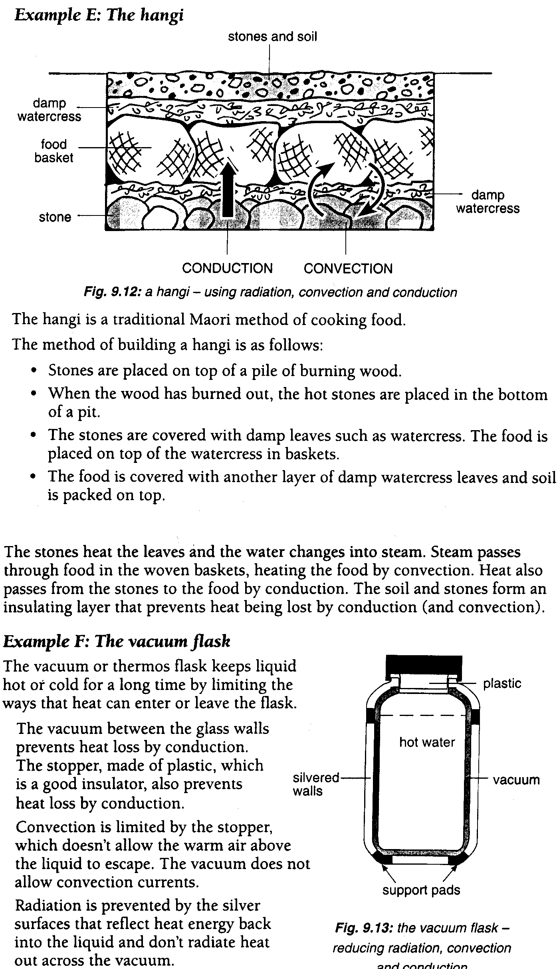
Heat Transfer Experiments

For each one of the following, observe carefully what happens; record this. Then, using scientific terms, explain why it happened.
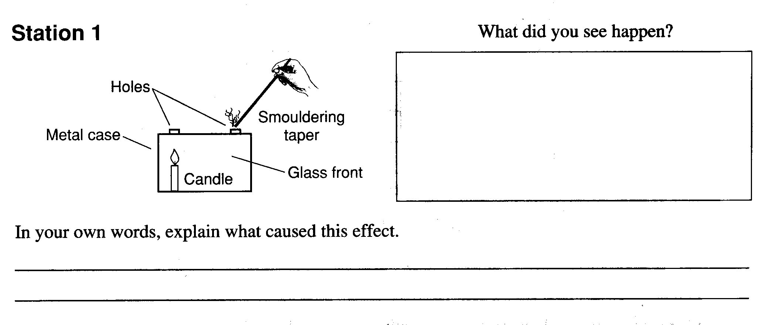
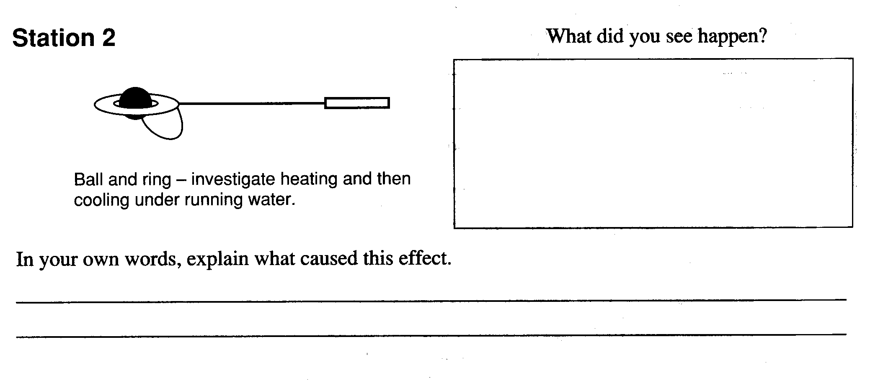
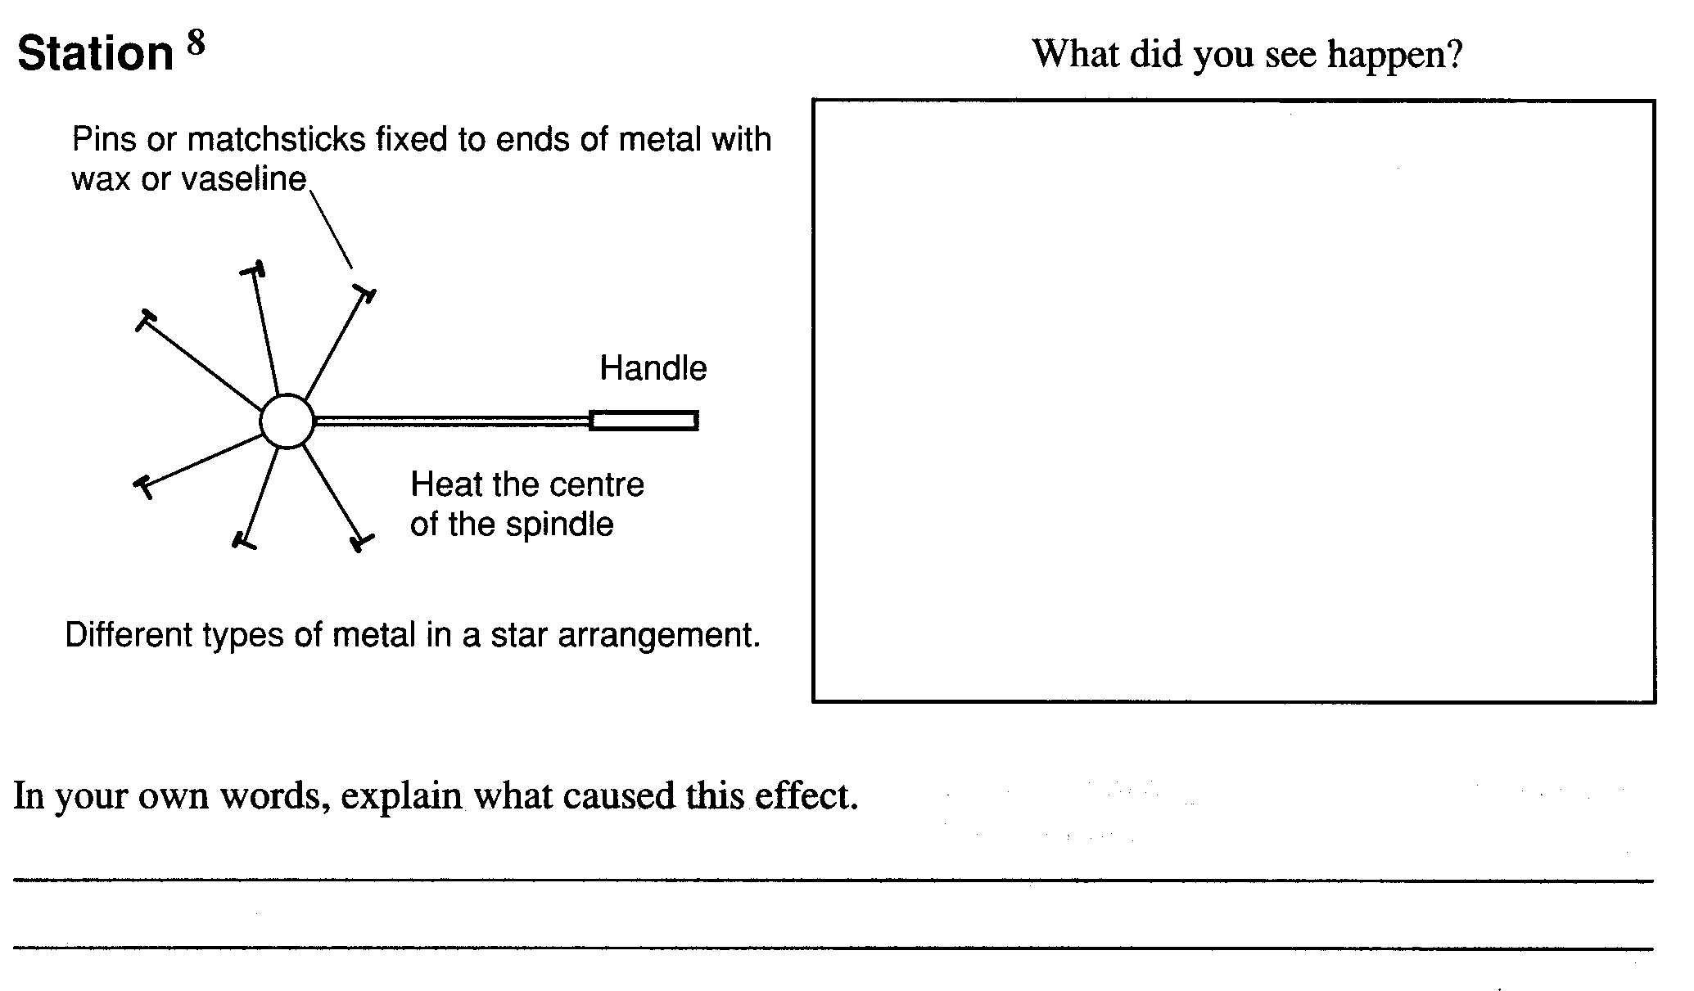
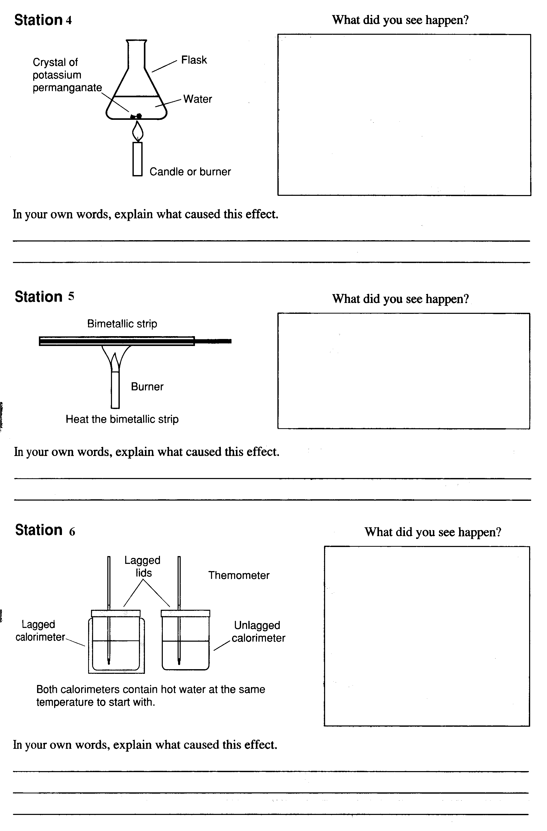
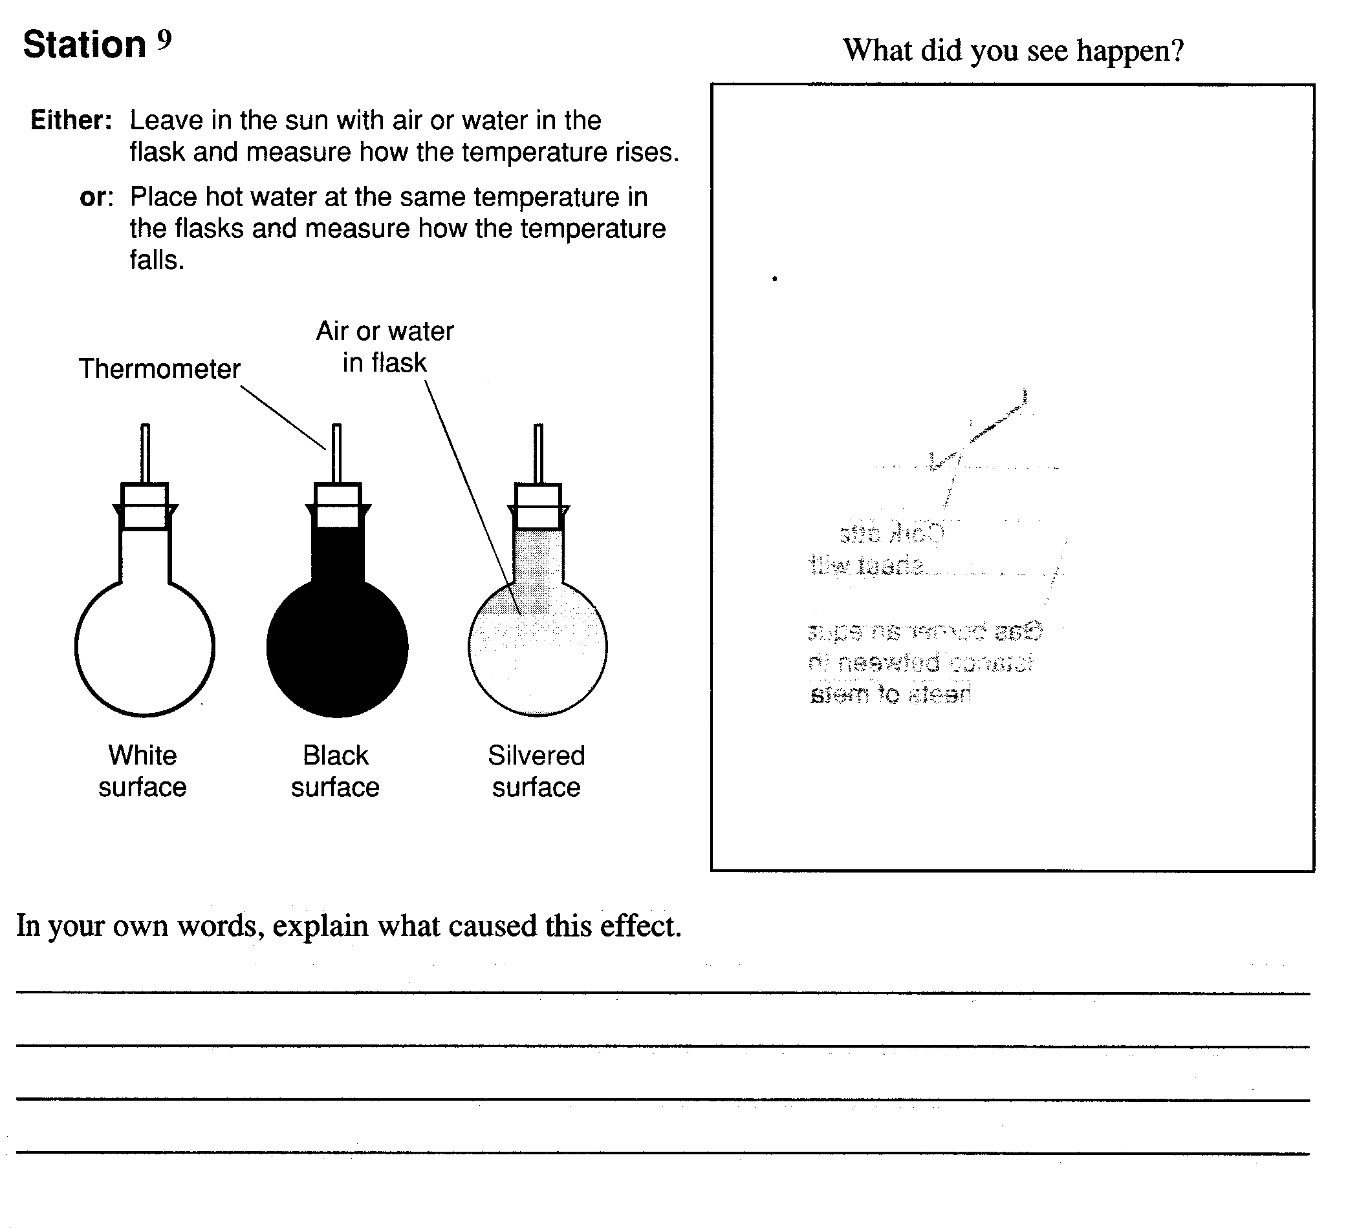

Planning, Carrying Out and Reporting an Investigation

- Using the following example: How does temperature affect the production of carbon dioxide when vinegar is added to marble?

- The aim is the purpose of the investigation. It usually starts with “To find out / investigate/ determine……..”
- To determine whether temperature has an effect on the production of carbon dioxide in a chemical reaction

- The independent variable is the one that you are planning to change. You must specify how you will change this variable.
- In this example, you are going to change the temperature of the vinegar. You will change it by using 3 different temperatures; room, 30ºC and 40ºC

- The dependent variable is the factor that you will measure or observe so as to collect data to answer your question. You must specify how you will measure it.
- The amount of carbon dioxide is the dependent variable. You will collect the gas in a graduated syringe so that you can measure its volume.

- The fixed or controlled variables are the factors that must be kept the same. You must specify how you will keep them the same. You need at least 3 of these
- The amount of marble must be the same in each test tube. You will weigh each piece to ensure they are the same mass.
- The amount of time for the reaction must be the same. You will use a stopwatch to time each one for 2 minutes
- The amount of vinegar must be the same. You will use a measuring cylinder to measure out 50mL of vinegar for each test.

- To achieve reliable results you must repeat your experiment at least 3 times so as to get consistency of data.

- The equipment list and method are very important. You must give a PRECISE step-by step account of how you will carry out the experiment. Diagrams are GREAT!!
- Weigh out 9 pieces of marble and ensure they are the same mass.
- Measure 50mL vinegar into each of 3 test tubes and check they are the same temperature.
- At the same time, drop 1 piece of marble into each tube, set up graduated syringes on each of the test tubes to collect the gas and time for 2 minutes.
- At the end of 2 minutes, take the syringes off and record how much gas each one produced.
- Repeat steps 1-4 but this time, heat the vinegar to 30ºC before putting into the test tubes
- Repeat again but heat the vinegar to 40ºC before putting into the test tubes

- The results should be presented in a table and an appropriate graph

- The discussion, evaluation and conclusion should explain
- An intepretation of the results (ie the pattern or non pattern that can be seen)
- An explanation of the science that relates to the results,
- explanations of where things may have gone wrong,
- or incorrect experimental technique
- or why you changed your initial plan
- and lastly, a concluding statement that relates to the initial aim.

- The graph shows that the higher the temperature, the more carbon dioxide produced. This is because the particles are moving faster when they are heated, so the reaction is quicker and more gas can be produced. A problem we had was coordinating the graduated syringe to be placed on top of the testtube quickly and without fumbling. We had to repeat the first temperature again because one person was incorrectly measuring 50mL of vinegar. We didn’t change any parts of our plan as it seemed to work quite well. We found that temperature does play a part in the amount of carbon dioxide produced, the warmer the acid, the more gas was formed. It would be interesting to investigate even warmer temperatures to see if there is an upper limit on the amount of carbon dioxide gas produced.

Investigation Plan Sheet: Student name:
- Purpose / Aim of investigation

Hypothesis or Prediction:

- Independent Variable [The variable that will be changed]

Give a suitable range of values for this variable

- Dependent variable [The variable that will be measured or observed in order to collect data]

How will it be measured or observed?

- Fixed/Control Variables - other variables you think are important in this investigation that will have to be controlled to make it a fair test?
Variable | What influence could this have on your investigation and how will this variable be kept the same (controlled) or measured?
- How will you ensure that your results are reliable? (e.g. sources of error, bias, and sufficient data)

- List the equipment you will need:

- Use the information questions 1 to 7 to write a method for carrying out your investigation.
- Your method must have enough detail to enable another student to repeat the experiment.
- Draw diagrams if appropriate.

Continue on a new page if needed.
Renewable and Non Renewable Energy Resources

- Most of the energy used in homes is electrical
- Some of this energy is produced from non-renewable sources of energy – oil, coal, gas
- Before these supplies run out, we will have to find other renewable sources such as the sun, waves, wind.
- In NZ, 73% of our electricity generation is via a renewable source called hydro-electric generation. This uses the energy of gravity in falling water to spin a turbine which generates electricity.

Each group is going to be given a specific energy resource to research and present a poster on to be peer assessed.
Hydroelectric, wind, fossil fuels, geothermal, waves, biomass, solar
- Where does this resource come from?
- Is it renewable or non renewable?
- Explanation and diagram showing the basics of how this source works
- Is it used in NZ at present? If not, can it be?

Video: The Clyde Dam (and worksheet)

Practice Test: Using Notemaker sheets.

Your name:
Peer Assessment of Energy Resources poster

Name of energy resource: Poor Excellent
1. Has all the information asked for been presented? 1 2 3 4 5
2. Can you understand the information presented? 1 2 3 4 5
3. Has the poster got lots of colour and “wow” factor? 1 2 3 4 5
4. Is the information and diagrams well spaced out? 1 2 3 4 5

Any other comments?

Name of energy resource: Poor Excellent
1. Has all the information asked for been presented? 1 2 3 4 5
2. Can you understand the information presented? 1 2 3 4 5
3. Has the poster got lots of colour and “wow” factor? 1 2 3 4 5
4. Is the information and diagrams well spaced out? 1 2 3 4 5

Any other comments?

Name of energy resource: Poor Excellent
1. Has all the information asked for been presented? 1 2 3 4 5
2. Can you understand the information presented? 1 2 3 4 5
3. Has the poster got lots of colour and “wow” factor? 1 2 3 4 5
4. Is the information and diagrams well spaced out? 1 2 3 4 5

Any other comments?

Name of energy resource: Poor Excellent
1. Has all the information asked for been presented? 1 2 3 4 5
2. Can you understand the information presented? 1 2 3 4 5
3. Has the poster got lots of colour and “wow” factor? 1 2 3 4 5
4. Is the information and diagrams well spaced out? 1 2 3 4 5

Any other comments?

Name of energy resource: Poor Excellent
1. Has all the information asked for been presented? 1 2 3 4 5
2. Can you understand the information presented? 1 2 3 4 5
3. Has the poster got lots of colour and “wow” factor? 1 2 3 4 5
4. Is the information and diagrams well spaced out? 1 2 3 4 5

Any other comments?

